Options for the reduction of flooding in the Cowbridge area

The following are measures the Environment Agency uses to decide on the best flood alleviation scheme for an area.

‘to provide sustainable flood defences which prevent deaths, minimise property damage and reduce distress from flooding’.

‘to provide:
technically feasible,
economically viable and
environmentally sustainable
flood defence measures.’

The Environment Agency looked at many ways to reduce the flood risk in the Cowbridge area. Which option would you chose?

Complete the spider diagrams to compare the advantages and disadvantages of each of the following options.

Option A – Do Nothing

This option assumes that all existing maintenance operations will cease. Stopping channel clearance and control of bankside vegetation will lead to a gradual blockage of the channel and structures due to the collection of debris, silt and fallen trees, and the encroachment of vegetation into the river channel. The net effect will be a reduction in carrying capacity and more frequent and more severe flooding.

Option B – Do Minimum
The ‘Do Minimum’ option assumes that the Environment Agency will continue the current level of maintenance activity, such as grass cutting, debris clearance and desilting of main structures to maintain the existing river channel capacity.

Option C – Flood Warning
Currently there is no Flood Warning scheme in operation within the River Thaw catchment. The catchment is covered under a general Flood Watch warning issued to South-East Wales via local radio and TV. There is no Automated Voice Messaging (AVM) service set up in the locality.

The flood risk area is very near the river source so any worthwhile warning would have to rely on predictive rainfall radar. Experience within other areas suggests that up to 6 hours advance warning of severe weather could be achieved. However, there is some doubt as to whether this service could provide sufficiently detailed information to enable the level of risk to be determined and appropriate warnings issued.

Schemes involving New Construction
Maps and photographs are found in Activities 7 options for flood defence

Option D Protection of Llanblethian only
Raised defences & new watercourse.

Raised defences to the north of the village and along the left bank through the centre of the village. Removal of the culvert which conveys flows from the water meadow to the north of the village. The stream would also be realigned to the south to improve channel capacity through the village.

Option E Flood Protection of both Cowbridge & Llanblethian

Option E1 – Flood Storage upstream of Cowbridge.

Use the extensive natural flood plains upstream of Cowbridge as a flood storage area. This would involve the construction of an earth bund across the flood plain. A flow control structure would control the ‘carry on’ flows in the River Thaw. The structure would limit the flow through Cowbridge and Llanblethian at times of peak flows and would store the excess flows on the flood plain upstream.

An activity, and information on this is found in Activity 7 Options for flood defence

Option E2 – Large tunnel diversion between Cowbridge & Llanblethian.
Construction of a 2.25m diameter bypass tunnel from upstream of Cowbridge to a point downstream of Llanblethian.

Option E3 – Smaller flood storage area & raised defences in Llanblethian.
A smaller flood storage area would be used, sufficient to offer protection to Cowbridge only. Raised defences would be required to offer the requisite protection to Llanblethian.

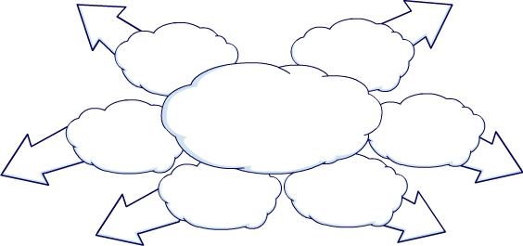
Option A – Do Nothing
Technical
Complexity
Impact - Environmental
Impact - Physical
Impact - Human
Impact - Social
Cost - Economic

Option B – Do Minimum
Technical
Complexity
Impact - Environmental
Impact - Physical
Impact - Human
Impact - Social
Cost - Economic

Option C – Flood Warning
Technical
Complexity
Impact - Environmental
Impact - Physical
Impact - Human
Impact - Social
Cost - Economic

Option D – Protection of Llanblethian
Technical
Complexity
Impact - Environmental
Impact - Physical
Impact - Human
Impact - Social
Cost - Economic

Option E1 – Flood storage upstream of Cowbridge
Technical
Complexity
Impact - Environmental
Impact - Physical
Impact - Human
Impact - Social
Cost - Economic

Technical
Complexity
Cost - Economic

Option E2 – Large tunnel diversion between Cowbridge and Llanblethian

Impact - Social
Impact - Environmental

Impact - Physical
Impact - Human

Option E3 – Smaller flood storage area and raised defences in Llanblethian
Technical
Complexity
Impact - Environmental
Impact - Physical
Impact - Human
Impact - Social
Cost - Economic

